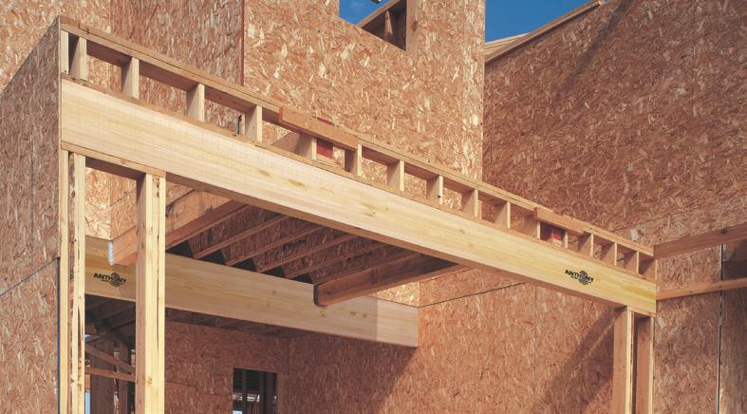
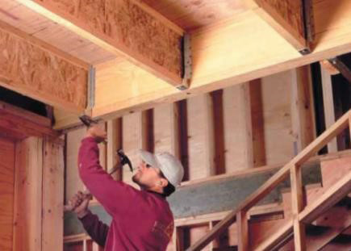
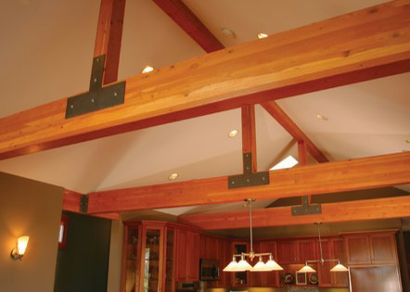
Frame for Success: Avoid Call Backs & Failed Inspections

Hosted By:
Sponsored By:

Flagler Home Builders Association

Location:
Flagler Home Builders Association
4863 Palm Coast Parkway NW, Suite 1
Palm Coast, Florida 32137

Date/Time:
Tuesday, July 25, 2023

12:00 pm – 1:00 pm

Free to attend.
Lunch will be provided.
RSVP required.

Contact
Samantha Dawson
Flagler HBA
Phone: 386.445-9399
samantha@flagerhba.com

1 Hour General Credit, FL CILB

Recognizing Framing Errors

Based on hundreds of job site reviews, APA has assembled a list of the most common wood construction framing

and sheathing challenges found in today’s wood frame construction. This presentation is intended for design professionals to highlight potential framing detail improvements in construction drawings; it is aimed at builder’s site staff that is charged with oversight of framing installation implementation, not only reducing call backs but failed inspections; and it provides the code official with a review of fundamental code compliant elements related to engineered wood products that ensures life safety. This session, presented by APA’s Stephanie Thomas- Rees on March 29, will examine these common framing errors and provide practical solutions for avoiding them in future construction. Best practices for floor and wall sheathing attachments will be covered. Using these best practices helps prevent common callbacks like wavy roofs and squeaky floors.

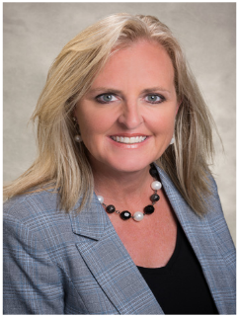
Stephanie Thomas-Rees

Stephanie is an Engineered Wood Specialist at APA – The Engineered Wood Association. From her location in Central Florida, Stephanie consults with builders, designers, code officials and suppliers on using engineered wood products efficiently and cost effectively. Stephanie is an experienced designer and energy professional with a bachelor’s degree in architectural design from Clemson University and a master’s degree in energy efficient building from Oxford Brookes University. As a building science professional, Stephanie’s past roles include project architect, designated energy efficiency coordinator, code coordinator, and adjunct professor teaching sustainable design and building materials.

© 2023 APA – The Engineered Wood Association www.apawood.org

